Project Report: Unlocking the Economics of Cinema
An IMDb Box Office & Critical Reception Analysis Prepared by: Sanskar
Tools Utilized: PostgreSQL, Microsoft Power BI
1. Executive Summary
The objective of this project was to analyze the historical box office performance, critical reception, and genre trends of the top 1,000 highest-rated movies on IMDb. By combining raw SQL data manipulation with advanced Power BI visualization, this project transforms flat data into an interactive business dashboard. The resulting application allows stakeholders to instantly identify which directors, actors, and genres historically drive the highest financial returns and audience satisfaction.
2. Phase 1: Backend Data Architecture (PostgreSQL)
Before visualization, the raw dataset required extensive cleaning and structuring to ensure accuracy. Key backend processes included:
- Data Cleansing: Standardizing text formats and handling null values within the gross revenue and runtime columns to ensure accurate aggregations.
- Metric Engineering: Developing custom SQL queries to aggregate total box office gross by Director and Lead Actor (Star1), shifting the focus from individual movie success to overall franchise/personnel value.
- Trend Analysis: Grouping data by Released_Year and Genre to prepare macro-level timeline datasets for frontend ingestion.
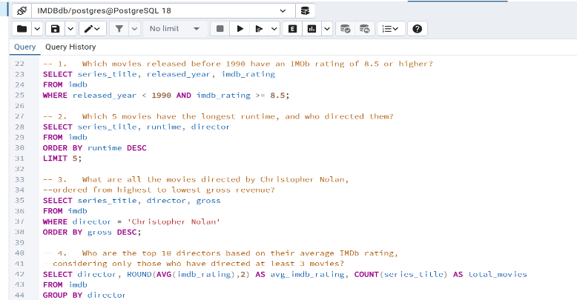
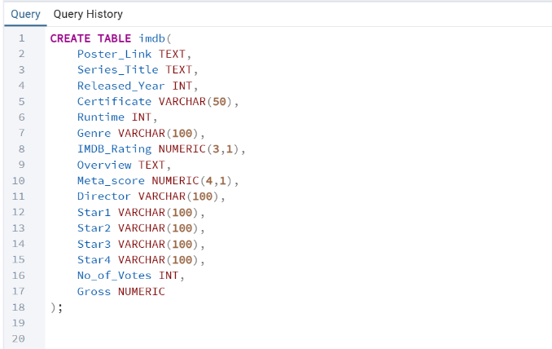

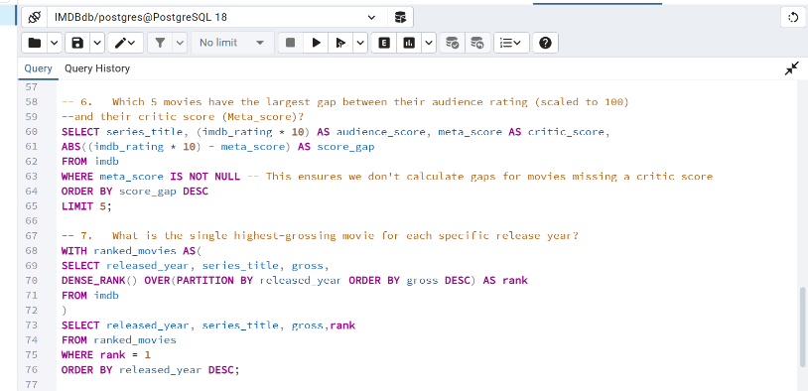
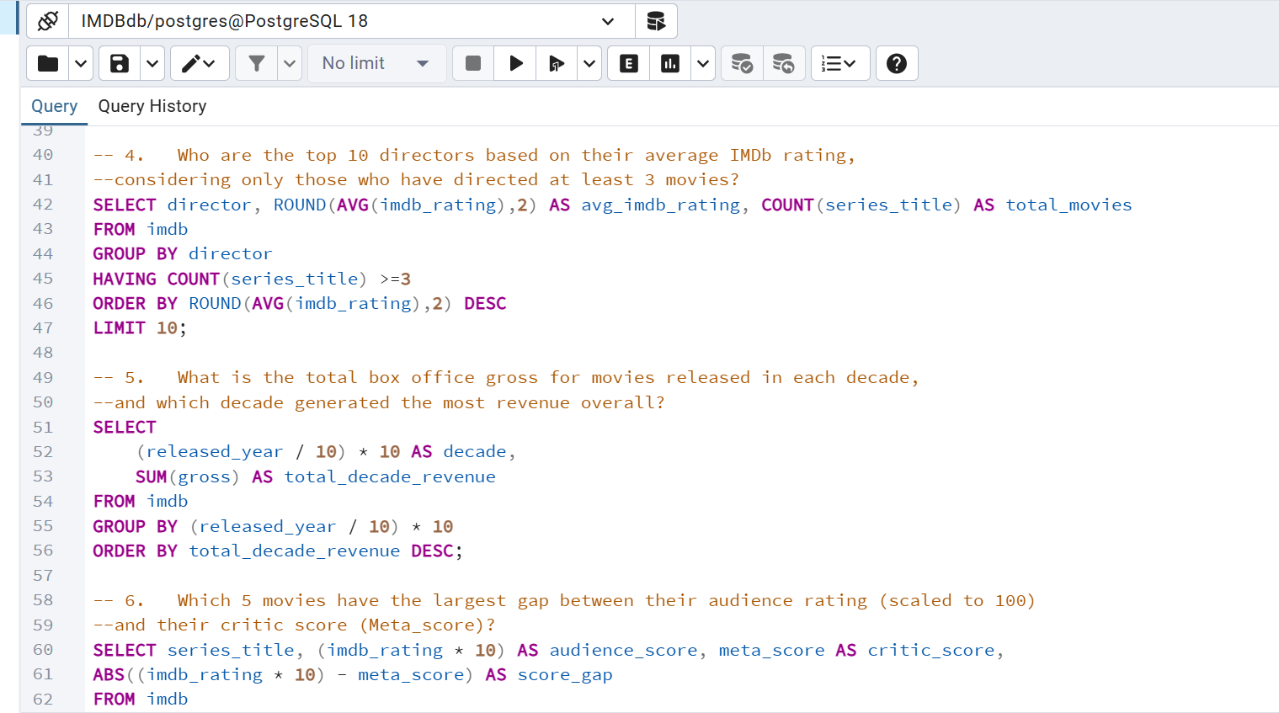

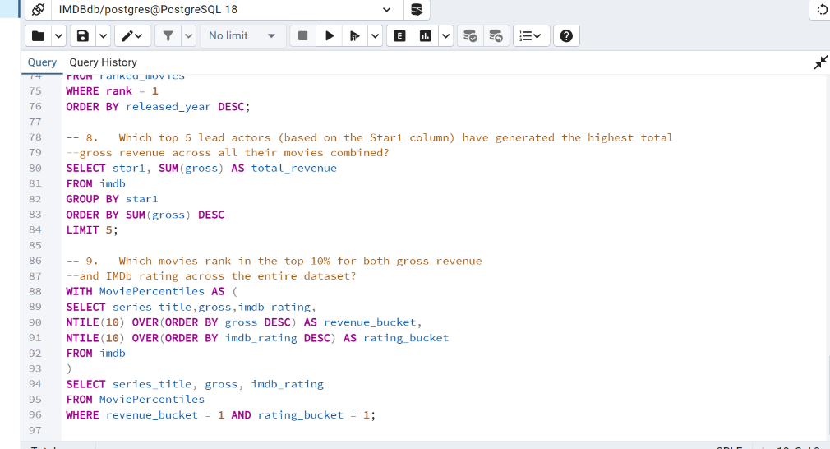

3. Phase 2: Frontend Dashboard Design (Power BI)
The visualization phase focused on creating a highly interactive, intuitive, and visually striking "dark mode" web-app experience.
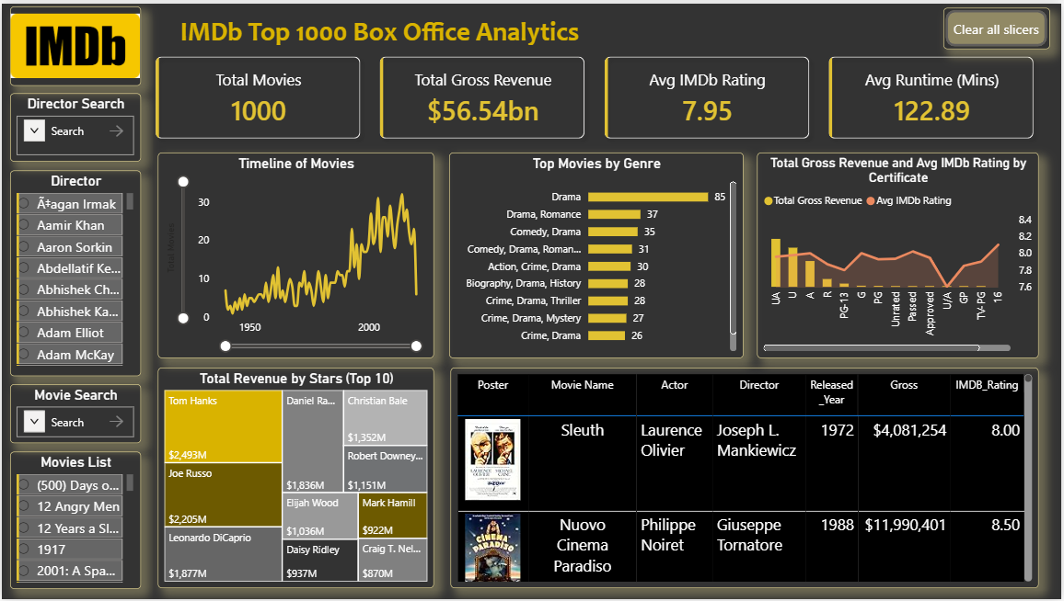

Key Dashboard Features Built:
- Dynamic Control Panel (Left Axis): Engineered a dedicated navigation panel featuring searchable dropdown slicers. This allows users to instantly filter the entire 1,000-movie database by specific Directors or Movie Titles.
- Macro-Trend Visualization (Top Row): * Deployed a KPI ribbon tracking Total Movies, Total Gross Revenue ($56.54bn), Average IMDb Rating (7.95), and Average Runtime.
  - Built a Time Series Line Chart to map the volume of top-rated movies released from 1950 to 2000.
  - Utilized a Horizontal Bar Chart to rank the most frequent top-tier movie genres (led by Drama).
- Micro-Level Drill Downs (Bottom Row):
  - Designed a custom Treemap to visualize "Star Power," highlighting the actors (e.g., Tom Hanks, Leonardo DiCaprio) who have generated the highest cumulative box office revenue.
  - Integrated a dynamic Matrix Table featuring high-resolution movie posters via image URLs, providing granular row-level data (Release Year, Gross, Rating) that updates automatically based on user selections.
4. Key Business Insights
Based on the data visualized in the dashboard, three primary market trends were identified:
- Volume vs. Revenue Disconnect: While pure "Drama" is the most frequently produced top-tier genre (85 movies), composite genres (like Action/Crime/Drama) often yield higher financial returns per release.
- The Run-Time Evolution: The line chart indicates a steady historical increase in both the volume of top-rated movies and their average runtimes (averaging 122.89 minutes), suggesting modern audiences are willing to tolerate longer films if the critical quality is high.
- Concentration of Star Power: The Treemap reveals a heavy concentration of box office wealth. A small fraction of lead actors commands a disproportionately massive share of the $56.54 billion total gross, highlighting the financial value of casting established "bankable" stars.

